Chapter 11
Managing Bond Portfolios

- Duration can be thought of as a weighted average of the ‘maturities’ of the cash flows paid to holders of the perpetuity, where the weight for each cash flow is equal to the present value of that cash flow divided by the total present value of all cash flows. For cash flows in the distant future, present value approaches zero (i.e., the weight becomes very small) so that these distant cash flows have little impact, and eventually, virtually no impact on the weighted average.

- A low coupon, long maturity bond will have the highest duration and will, therefore, produce the largest price change when interest rates change.

- A rate anticipation swap should work. The trade would be to long the corporate bonds and short the treasuries. A relative gain will be realized when rate spreads return to normal.

- -25 = -(D/1.06)x.0025x1050…solving for D = 10.09

- d.

- The increase will be larger than the decrease in price.

- While it is true that short-term rates are more volatile than long-term rates, the longer duration of the longer-term bonds makes their rates of return more volatile. The higher duration magnifies the sensitivity to interest-rate savings. Thus, it can be true that rates of short-term bonds are more volatile, but the prices of long-term bonds are more volatile.

- Computation of duration:
  - YTM = 6%

(1) | (2) | (3) | (4) | (5)
Time until Payment (Years) | Payment | Payment Discounted at 6% | Weight | Column (1)  ×  Column (4)
1 | 60 | 56.60 | 0.0566 | 0.0566
2 | 60 | 53.40 | 0.0534 | 0.1068
3 | 1060 | 890.00 | 0.8900 | 2.6700
Column Sum: |  | 1000.00 | 1.0000 | 2.8334

Duration = 2.833 years

  - YTM = 10%

(1) | (2) | (3) | (4) | (5)
Time until Payment (Years) | Payment | Payment Discounted at 10% | Weight | Column (1)  ×  Column (4)
1 | 60 | 54.55 | 0.0606 | 0.0606
2 | 60 | 49.59 | 0.0551 | 0.1101
3 | 1060 | 796.39 | 0.8844 | 2.6531
Column Sum: |  | 900.53 | 1.0000 | 2.8238

Duration = 2.824 years, which is less than the duration at the YTM of 6%

- The percentage bond price change is:

– Duration × 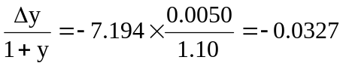 or a 3.27% decline

- Computation of duration, interest rate = 10%:

(1) | (2) | (3) | (4) | (5)
Time until Payment (Years) | Payment  (in millions of dollars) | Payment Discounted  At 10% | Weight | Column (1)  ×  Column (4)
1 | 1 | 0.9091 | 0.2744 | 0.2744
2 | 2 | 1.6529 | 0.4989 | 0.9977
3 | 1 | 0.7513 | 0.2267 | 0.6803
Column Sum: |  | 3.3133 | 1.0000 | 1.9524

Duration = 1.9524 years

- The duration of the perpetuity is: (1 + y)/y = 1.10/0.10 = 11 years
Let w be the weight of the zero-coupon bond. Then we find w by solving:

(w × 1) + [(1 – w) × 11] = 1.9523 ⇒ w = 9.048/10 = 0.9048

Therefore, your portfolio should be 90.48% invested in the zero and 9.52% in the perpetuity.

- The percentage bond price change will be:

– Duration × 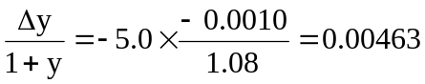 or a 0.463% increase

  - Bond B has a higher yield to maturity than bond A since its coupon payments and maturity are equal to those of A, while its price is lower. (Perhaps the yield is higher because of differences in credit risk.) Therefore, the duration of Bond B must be shorter.
  - Bond A has a lower yield and a lower coupon, both of which cause it to have a longer duration than that of Bond B. Moreover, Bond A cannot be called. Therefore, the maturity of Bond A is at least as long as that of Bond B, which implies that the duration of Bond A is at least as long as that of Bond B.

- Choose the longer-duration bond to benefit from a rate decrease.
  - The Aaa-rated bond has the lower yield to maturity and therefore the longer duration.

  - The lower-coupon bond has the longer duration and more de facto call protection.

  - The lower coupon bond has the longer duration.

  - The present value of the obligation is $17,832.65 and the duration is 1.4808 years, as shown in the following table:
Computation of duration, interest rate = 8%
(1) | (2) | (3) | (4) | (5)
Time until Payment (Years) | Payment | Payment Discounted  at 8% | Weight | Column (1)  ×  Column (4)
1 | 10,000 | 9,259.26 | 0.5192 | 0.51923
2 | 10,000 | 8,573.39 | 0.4808 | 0.96154
Column Sum: |  | 17,832.65 | 1.0000 | 1.48077

  - To immunize the obligation, invest in a zero-coupon bond maturing in 1.4808 years. Since the present value of the zero-coupon bond must be $17,832.65, the face value (i.e., the future redemption value) must be:
$17,832.65 × (1.08)1.4808 = $19,985.26

  - If the interest rate increases to 9%, the zero-coupon bond would fall in value to:
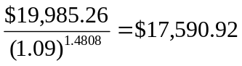
The present value of the tuition obligation would fall to $17,591.11, so that the net position changes by $0.19.
If the interest rate falls to 7%, the zero-coupon bond would rise in value to:
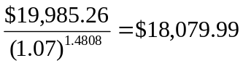
The present value of the tuition obligation would increase to $18,080.18, so that the net position changes by $0.19.
The reason the net position changes at all is that, as the interest rate changes, so does the duration of the stream of tuition payments.

  - PV of obligation = $2 million/0.16 = $12.5 million
Duration of obligation = 1.16/0.16 = 7.25 years
Call w the weight on the five-year maturity bond (with duration of 4 years). Then:
(w × 4) + [(1 – w) × 11] = 7.25 ⇒ w = 0.5357
Therefore:
0.5357 × $12.5 = $6.7 million in the 5-year bond, and
0.4643 × $12.5 = $5.8 million in the 20-year bond.

  - The price of the 20-year bond is:
[60 × Annuity factor(16%,20)] + [1000 × PV factor(16%, 20)] = $407.12
Therefore, the bond sells for 0.4071 times its par value, so that:
Market value = Par value × 0.4071
$5.8 million = Par value × 0.4071 ⇒ Par value = $14.25 million
Another way to see this is to note that each bond with par value $1000 sells for $407.11. If total market value is $5.8 million, then you need to buy:
$5,800,000/407.11 = 14,250 bonds
Therefore, total par value is $14,250,000.

  - The duration of the perpetuity is: 1.05/0.05 = 21 years
Let w be the weight of the zero-coupon bond, so that we find w by solving:
(w × 5) + [(1 – w) × 21] = 10 ⇒ w = 11/16 = 0.6875
Therefore, the portfolio will be 11/16 invested in the zero and 5/16 in the perpetuity.

  - The zero-coupon bond will then have a duration of 4 years while the perpetuity will still have a 21-year duration. To have a portfolio with duration equal to nine years, which is now the duration of the obligation, we again solve for w:
(w × 4) + [(1 – w) × 21] = 9 ⇒ w = 12/17 = 0.7059
So the proportion invested in the zero increases to 12/17 and the proportion in the perpetuity falls to 5/17.

- Macaulay Duration and Modified Duration are calculated using Excel as follows:

Inputs |  | Formula in column B
Settlement date | 5/27/2010 | =DATE(2010,5,27)
Maturity date | 11/15/2019 | =DATE(2019,11,15)
Coupon rate | 0.07 | 0.07
Yield to maturity | 0.08 | 0.08
Coupons per year | 2 | 2
Outputs
Macaulay Duration | 6.9659 | =DURATION(B2,B3,B4,B5,B6)
Modified Duration | 6.6980 | =MDURATION(B2,B3,B4,B5,B6)

- Macaulay Duration and Modified Duration are calculated using Excel as follows:

Inputs |  | Formula in column B
Settlement date | 5/27/2010 | =DATE(2010,5,27)
Maturity date | 11/15/2019 | =DATE(2019,11,15)
Coupon rate | 0.07 | 0.07
Yield to maturity | 0.08 | 0.08
Coupons per year | 1 | 1
Outputs
Macaulay Duration | 6.8844 | =DURATION(B2,B3,B4,B5,B6)
Modified Duration | 6.3745 | =MDURATION(B2,B3,B4,B5,B6)

Generally, we would expect duration to increase when the frequency of payment decreases from one payment per year to two payments per year, because more of the bond’s payments are made further in to the future when payments are made annually. However, in this example, duration decreases as a result of the timing of the settlement date relative to the maturity date and the interest payment dates. For annual payments, the first payment is $70 paid on November 15, 2010. For semi-annual payments, the first $70 is paid as follows: $35 on November 15, 2010 and $35 on May 15, 2010, so the weighted average “maturity” these payments is shorter than the “maturity” of the $70 payment on November 15, 2010 for the annual payment bond.

  - The duration of the perpetuity is: 1.10/0.10 = 11 years
The present value of the payments is: $1 million/0.10 = $10 million
Let w be the weight of the five-year zero-coupon bond and therefore (1 – w) is the weight of the twenty-year zero-coupon bond. Then we find w by solving:
(w × 5) + [(1 – w) × 20] = 11 ⇒ w = 9/15 = 0.60
So, 60% of the portfolio will be invested in the five-year zero-coupon bond and 40% in the twenty-year zero-coupon bond.
Therefore, the market value of the five-year zero is:
$10 million × 0.60 = $6 million
Similarly, the market value of the twenty-year zero is:
$10 million × 0.40 = $4 million

  - Face value of the five-year zero-coupon bond is:
$6 million × (1.10)5 = $9.66 million
Face value of the twenty-year zero-coupon bond is:
$4 million ×(1.10)20 = $26.91 million

- Convexity is calculated using the Excel spreadsheet below:

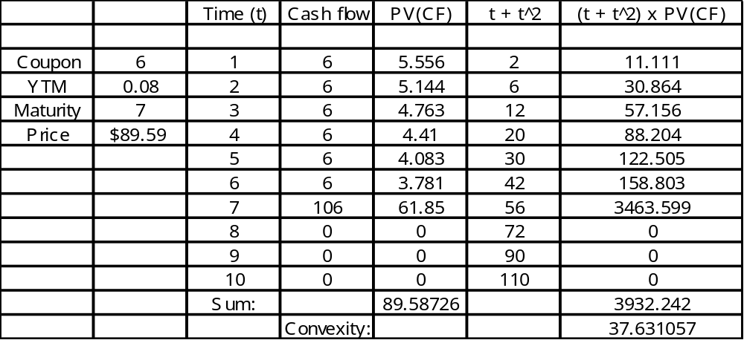

  - Interest rate = 12%

 | Time until Payment (Years) | Payment | Payment Discounted at 12% | Weight | Time  ×  Weight
8% coupon | 1 | 80 | 71.429 | 0.0790 | 0.0790
 | 2 | 80 | 63.776 | 0.0706 | 0.1411
 | 3 | 1080 | 768.723 | 0.8504 | 2.5513
 |  | Sum: | 903.927 | 1.0000 | 2.7714

Zero-coupon | 1 | 0 | 0.000 | 0.0000 | 0.0000
 | 2 | 0 | 0.000 | 0.0000 | 0.0000
 | 3 | 1000 | 711.780 | 1.0000 | 3.0000
 |  | Sum: | 711.780 | 1.0000 | 3.0000
At a higher discount rate, the weights of the later payments of the coupon bond fall and those of the earlier payments rise. So duration falls. For the zero, the weight of the payment in three years remains at 1.0, and duration therefore remains at 3 years.

  - Continue to use a yield to maturity of 12%:

 | Time until Payment (Years) | Payment | Payment Discounted at 12% | Weight | Time  ×  Weight
8% coupon | 1 | 120 | 107.143 | 0.1071 | 0.1071
 | 2 | 120 | 95.663 | 0.0957 | 0.1913
 | 3 | 1120 | 797.194 | 0.7972 | 2.3916
 |  | Sum: | 1000.000 | 1.0000 | 2.6901
The weights of the earlier payments are higher when the coupon increases. Therefore, duration falls.

Time until Payment (Years) | Payment | Payment Discounted at 10% | t² + t | t² + t  ×  PV
1 | 80 | 72.727 | 2 | 145.455
2 | 80 | 66.116 | 6 | 396.694
3 | 1080 | 811.420 | 12 | 9737.040
 | Sum: | 950.263 |  | 10279.189
Convexity = [10,279.189/(950.263 × (1.10)²] = 8.939838

  - At a YTM of 10%, the zero-coupon bond with three-year maturity sells for 751.315 (see Spreadsheet 10.1). Its convexity is:

- Using a financial calculator, we find that the price of the bond is:
For yield to maturity of 7%: $1,620.45
For yield to maturity of 8%: $1,450.31
For yield to maturity of 9%: $1,308.21

Using the Duration Rule, assuming yield to maturity falls to 7%:
Predicted price change = – Duration 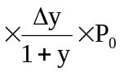
= –11.54 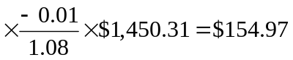
Therefore: Predicted price = $154.97 + $1,450.31 = $1,605.28
The actual price at a 7% yield to maturity is $1,620.45. Therefore:
% error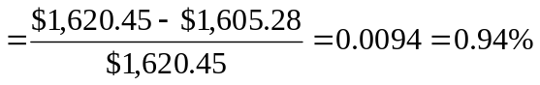(too low)
Using the Duration Rule, assuming yield to maturity increases to 9%:
Predicted price change = – Duration
= –11.54 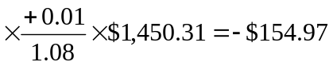
Therefore: Predicted price = –$154.97 + $1,450.31 = $1,295.34
The actual price at a 9% yield to maturity is $1,308.21. Therefore:
% error 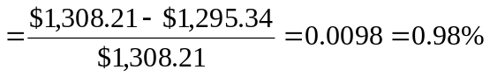(too low)
Using Duration-with-Convexity Rule, assuming yield to maturity falls to 7%:
Predicted price change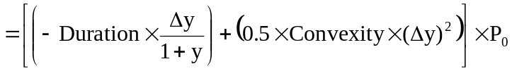
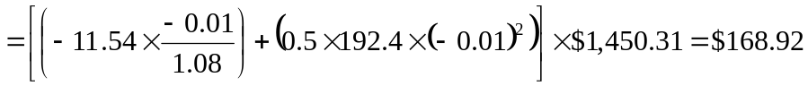
Therefore: Predicted price = $168.92 + $1,450.31 = $1,619.23
The actual price at a 7% yield to maturity is $1,620.45. Therefore:
% error 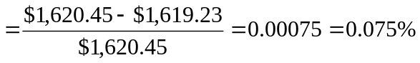(too low)
Using Duration-with-Convexity Rule, assuming yield to maturity rises to 9%:
Predicted price change
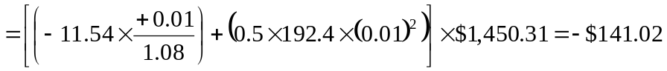
Therefore: Predicted price = –$141.02 + $1,450.31 = $1,309.29
The actual price at a 9% yield to maturity is $1,308.21. Therefore:
% error 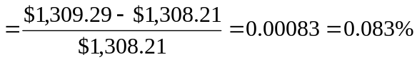(too high)
Conclusion: The duration-with-convexity rule provides more accurate approximations to the actual change in price. In this example, the percentage error using convexity with duration is less than one-tenth the error using duration only to estimate the price change.

- You should buy the three-year bond because it will offer a 9% holding-period return over the next year, which is greater than the return on either of the other bonds, as shown below:
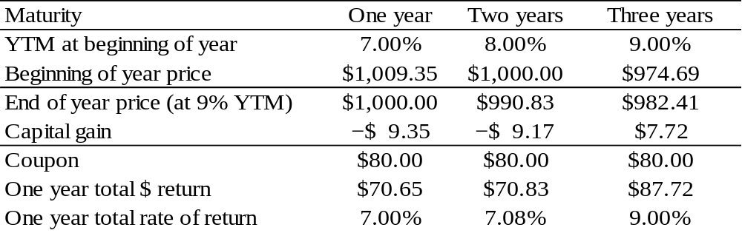

- The maturity of the 30-year bond will fall to 25 years, and the yield is forecast to be 8%. Therefore, the price forecast for the bond is:
$893.25 [n = 25; i = 8; FV = 1000; PMT = 70]
At a 6% interest rate, the five coupon payments will accumulate to $394.60 after five years. Therefore, total proceeds will be:
$394.60 + $893.25 = $1,287.85
The five-year return is therefore: ($1,287.85/867.42) – 1 = 1.48469 – 1 = 48.469%
The annual rate of return is: (1.48469)^{(1/5)} –1 = 0.0822 = 8.22%
The maturity of the 20-year bond will fall to 15 years, and its yield is forecast to be 7.5%. Therefore, the price forecast for the bond is:
$911.73 [n = 15; i = 7.5; FV = 1000; PMT = 65]
At a 6% interest rate, the five coupon payments will accumulate to $366.41 after five years. Therefore, total proceeds will be:
$366.41 + $911.73 = $1,278.14
The five-year return is therefore: ($1,278.14/$879.50) – 1 = 1.45326 – 1 = 45.326%
The annual rate of return is: 1.45326^{(1/5)} – 1 = 0.0776 = 7.76%
The 30-year bond offers the higher expected return.

  - Using a financial calculator, we find that the price of the zero-coupon bond (with $1000 face value) is:
For yield to maturity of 8%: $374.84
For yield to maturity of 9%: $333.28
The price of the 6% coupon bond is:
For yield to maturity of 8%: $774.84
For yield to maturity of 9%: $691.79
Zero coupon bond
Actual % loss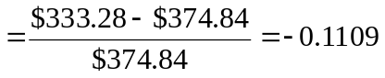, an 11.09% loss
The percentage loss predicted by the duration-with-convexity rule is:
Predicted % loss = [( –11.81) × 0.01] + [0.5 × 150.3 × (0.01)2]
= –0.1106, an 11.06% loss
Coupon bond
Actual % loss 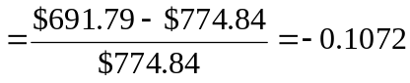, a 10.72% loss
The percentage loss predicted by the duration-with-convexity rule is:
Predicted % loss = [( –11.79) × 0.01] + [0.5 × 231.2 × (0.01)2]
= –0.1063, a 10.63% loss

  - Now assume yield to maturity falls to 7%. The price of the zero increases to $422.04, and the price of the coupon bond increases to $875.91.
Zero coupon bond
Actual % gain 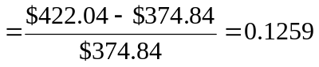, a 12.59% gain
The percentage gain predicted by the duration-with-convexity rule is:
Predicted % gain = [( –11.81) × (–0.01)] + [0.5 × 150.3 × (–0.01)2]
= 0.1256, a 12.56% gain
Coupon bond
Actual % gain 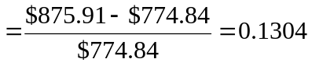, a 13.04% gain
The percentage gain predicted by the duration-with-convexity rule is:
Predicted % gain = [(–11.79) × (–0.01)] + [0.5 × 231.2 × (–0.01)2]
= 0.1295, a 12.95% gain

  - The 6% coupon bond (which has higher convexity) outperforms the zero regardless of whether rates rise or fall. This is a general property which can be understood by first noting from the duration-with-convexity formula that the duration effect resulting from the change in rates is the same for the two bonds because their durations are approximately equal. However, the convexity effect, which is always positive, always favors the higher convexity bond. Thus, if the yields on the bonds always change by equal amounts, as we have assumed in this example, the higher convexity bond always outperforms a lower convexity bond with the same duration and initial yield to maturity.

  - This situation cannot persist. No one would be willing to buy the lower convexity bond if it always underperforms the other bond. The price of the lower convexity bond will fall and its yield to maturity will rise. Thus, the lower convexity bond will sell at a higher initial yield to maturity. That higher yield is compensation for the lower convexity. If rates change only slightly, the higher yield-lower convexity bond will perform better; if rates change by a greater amount, the lower yield-higher convexity bond will do better.

CFA 1

C: Highest maturity, zero coupon
D: Highest maturity, next-lowest coupon
A: Highest maturity, same coupon as remaining bonds
B: Lower yield to maturity than bond E
E: Highest coupon, shortest maturity, highest yield of all bonds.

CFA 2

- Modified duration = 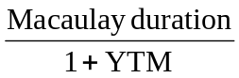
If the Macaulay duration is 10 years and the yield to maturity is 8%, then the modified duration is: 10/1.08 = 9.26 years

- For option-free coupon bonds, modified duration is better than maturity as a measure of the bond’s sensitivity to changes in interest rates. Maturity considers only the final cash flow, while modified duration includes other factors such as the size and timing of coupon payments and the level of interest rates (yield to maturity). Modified duration, unlike maturity, tells us the approximate proportional change in the bond price for a given change in yield to maturity.
- i. Modified duration increases as the coupon decreases.
ii. Modified duration decreases as maturity decreases.

CFA 3
  - Scenario (i): Strong economic recovery with rising inflation expectations. Interest rates and bond yields will most likely rise, and the prices of both bonds will fall. The probability that the callable bond will be called declines, so that it will behave more like the non-callable bond. (Notice that they have similar durations when priced to maturity.) The slightly lower duration of the callable bond will result in somewhat better performance in the high interest rate scenario.
Scenario (ii): Economic recession with reduced inflation expectations. Interest rates and bond yields will most likely fall. The callable bond is likely to be called. The relevant duration calculation for the callable bond is now its modified duration to call. Price appreciation is limited as indicated by the lower duration. The non-callable bond, on the other hand, continues to have the same modified duration and hence has greater price appreciation.

  - If yield to maturity (YTM) on Bond B falls by 75 basis points:
Projected price change = (modified duration) × (change in YTM)
= (–6.80) × (–0.75%) = 5.1%
So the price will rise to approximately $105.10 from its current level of $100.

  - For Bond A (the callable bond), bond life and therefore bond cash flows are uncertain. If one ignores the call feature and analyzes the bond on a “to maturity” basis, all calculations for yield and duration are distorted. Durations are too long and yields are too high. On the other hand, if one treats the premium bond selling above the call price on a “to call” basis, the duration is unrealistically short and yields too low.
The most effective approach is to use an option valuation approach. The callable bond can be decomposed into two separate securities: a non-callable bond and an option.
Price of callable bond = Price of non-callable bond – price of option
Since the option to call the bond always has a positive value, the price of the callable bond is always less than the price of the non-callable security.

CFA 4

  - The Aa bond initially has the higher yield to maturity (yield spread of 40 b.p. versus 31 b.p.), but the Aa bond is expected to have a widening spread relative to Treasuries. This will reduce rate of return. The Aaa spread is expected to be stable. Calculate comparative returns as follows:

Incremental return over Treasuries:
Incremental yield spread − (Change in spread × duration)
Aaa bond: 31 bp − (0 × 3.1) = 31 bp
Aa bond: 40 bp − (10 bp × 3.1) = 9 bp
So choose the Aaa bond.
  - Other variables that one should consider:
- Potential changes in issue-specific credit quality. If the credit quality of the bonds changes, spreads relative to Treasuries will also change.
- Changes in relative yield spreads for a given bond rating. If quality spreads in the general bond market change because of changes in required risk premiums, the yield spreads of the bonds will change even if there is no change in the assessment of the credit quality of these particular bonds.
- Maturity effect. As bonds near maturity, the effect of credit quality on spreads can also change. This can affect bonds of different initial credit quality differently.

CFA 5

∆P/P = −D* ∆y
For Strategy I:
5-year maturity: ∆P/P = −4.83 × (−0.75%) = 3.6225%
25-year maturity: ∆P/P = −23.81 × 0.50% = −11.9050%
Strategy I: ∆P/P = (0.5 × 3.6225%) + [0.5 × (−11.9050%)] = −4.1413%
For Strategy II:
15-year maturity: ∆P/P = −14.35 × 0.25% = −3.5875%

CFA 6
- For an option-free bond, the effective duration and modified duration are approximately the same. The duration of the bond described in Table 22A is calculated as follows:
Duration = (100.71 – 99.29)/(2 × 100 × 0.001) = 7.1

- The total percentage price change for the bond described in Table 22A is estimated as follows:
Percentage price change using duration = –7.90 × –0.02 × 100 = 15.80%
Convexity adjustment = 1.66%
Total estimated percentage price change = 15.80% + 1.66% = 17.46%

CFA 7
- i. Duration = (116.887 – 100.00)/(2 × 100 × 0.01) = 15.26
ii. Portfolio duration = (50/98.667) x 15.26 + (48.667/98.667) x 2.15 = 8.79

- The statement would only be correct if the portfolio consisted of only zero coupon bonds.

CFA 8

  - The two risks are price risk and reinvestment rate risk. The former refers to bond price volatility as interest rates fluctuate, the latter to uncertainty in the rate at which coupon income can be reinvested.

  - Immunization is the process of structuring a bond portfolio in such a manner that the value of the portfolio (including proceeds reinvested) will reach a given target level regardless of future changes in interest rates. This is accomplished by matching both the values and durations of the assets and liabilities of the plan. This may be viewed as a low-risk bond management strategy.

  - Duration matching is superior to maturity matching because bonds of equal duration -- not those of equal maturity -- are equally sensitive to interest rate fluctuations.

  - Contingent immunization allows for active bond management unless and until the surplus funding in the account is eliminated because of investment losses, at which point an immunization strategy is implemented. Contingent immunization allows for the possibility of above-market returns if the active management is successful.

CFA 9
The economic climate is one of impending interest rate increases. Hence, we will want to shorten portfolio duration.
  - Choose the short maturity (2014) bond.

  - The Arizona bond likely has lower duration. Coupons are about equal, but the Arizona yield is higher.

  - Choose the 9⅜ % coupon bond. Maturities are about equal, but the coupon is much higher, resulting in lower duration.

  - The duration of the Shell bond will be lower if the effect of the higher yield to maturity and earlier start of sinking fund redemption dominates the slightly lower coupon rate.

  - The floating rate bond has a duration that approximates the adjustment period, which is only six months.

CFA 10
- 4
- 4
- 4
- 2

CFA 11
- A manager who believes that the level of interest rates will change should engage in a rate anticipation swap, lengthening duration if rates are expected to fall, and shortening duration if rates are expected to rise.

- A change in yield spreads across sectors would call for an inter-market spread swap, in which the manager buys bonds in the sector for which yields are expected to fall and sells bonds in the sector for which yields are expected to rise.

- A belief that the yield spread on a particular instrument will change calls for a substitution swap in which that security is sold if its relative yield is expected to rise or is bought if its yield is expected to fall compared to other similar bonds.

CFA 12
  - This swap would have been made if the investor anticipated a decline in long-term interest rates and an increase in long-term bond prices. The deeper discount, lower coupon 2⅜% bond would provide more opportunity for capital gains, greater call protection, and greater protection against declining reinvestment rates at a cost of only a modest drop in yield.

  - This swap was probably done by an investor who believed the 24 basis point yield spread between the two bonds was too narrow. The investor anticipated that, if the spread widened to a more normal level, either a capital gain would be experienced on the Treasury note or a capital loss would be avoided on the Phone bond, or both. This swap might also have been done by an investor who anticipated a decline in interest rates, and who also wanted to maintain high current coupon income and have the better call protection of the Treasury note. The Treasury note would have much greater potential for price appreciation, in contrast to the Phone bond which would be restricted by its call price. Furthermore, if intermediate-term interest rates were to rise, the price decline of the higher quality, higher coupon Treasury note would likely be “cushioned” and the reinvestment return from the higher coupons would likely be greater.

  - This swap would have been made if the investor were bearish on the bond market. The zero coupon note would be extremely vulnerable to an increase in interest rates since the yield to maturity, determined by the discount at the time of purchase, is locked in. This is in contrast to the floating rate note, for which interest is adjusted periodically to reflect current returns on debt instruments. The funds received in interest income on the floating rate notes could be used at a later time to purchase long-term bonds at more attractive yields.

  - These two bonds are similar in most respects other than quality and yield. An investor who believed the yield spread between Government and Al bonds was too narrow would have made the swap either to take a capital gain on the Government bond or to avoid a capital loss on the Al bond. The increase in call protection after the swap would not be a factor except under the most bullish interest rate scenarios. The swap does, however, extend maturity another 8 years and yield to maturity sacrifice is 169 basis points.

  - The principal differences between these two bonds are the convertible feature of the Z mart bond, and, for the Lucky Duck debentures, the yield and coupon advantage, and the longer maturity. The swap would have been made if the investor believed some combination of the following:
First, that the appreciation potential of the Z mart convertible, based primarily on the intrinsic value of Z mart common stock, was no longer as attractive as it had been.
Second, that the yields on long-term bonds were at a cyclical high, causing bond portfolio managers who could take A2-risk bonds to reach for high yields and long maturities either to lock them in or take a capital gain when rates subsequently declined.
Third, while waiting for rates to decline, the investor will enjoy an increase in coupon income. Basically, the investor is swapping an equity-equivalent for a long- term corporate bond.

